Format and order of the required contents for writing a TDP
Ali Shamshiri ¹, Seyed mahbod Ghadiri ², and Alireza Babaei ³

Abstract—In this document, the necessary explanations regarding how to write the TDP are provided. All participating teams must complete all sections of this template based on their own innovations and ideas. Some sections or subsections mentioned in this template may not exist in certain robots; in such cases, teams may remove the relevant section or subsection from the file and adjust the numbering accordingly. This section of the paper should maximum 20 lines long.

Index Terms— Iran Open Competitions, Self-Driving Car League, Sample TDP Sheet, Robot Technical Description

I. INTRODUCTION
I
n this section, the team is introduced, and a general overview of the robot’s software and hardware is provided. This section of your writing should be maximum one column long.

II. Robot Design Description

A. Mechanical Hardware
Description of the robot body and the method used for its construction.

1) Details
In this section, it is essential to include an actual photograph of the robot taken from a top view, with rulers placed alongside it, (e.g. fig.1) to verify that the robot’s track width and wheelbase comply with the competition rules.
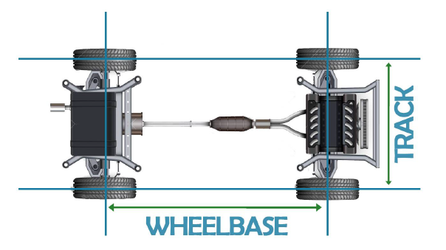
Fig. 1. This is a sample of a figure caption.

Additionally, the mechanical design details, following the exact format specified below, must be included at the end of this section.
- Overall dimensions:
- Weight:
- Body specifications:
- Motor type:
- Power source:
- Control type:
- Suspension system:

B. Electronic Hardware

1) Central Processing Unit
Introduction of the processors used, the role of each processor in the system, and related details.

2) Electronic Sensors
Explanation of the types of sensors used in the robot and their functions. Example: Obstacle detection sensor

C. Robot Software
Explanation of the different software components of the robot, including decision-making flowcharts, control logic, and related elements.

1) Machine Vision and Artificial Intelligence
In this section, it is essential to provide precise and detailed information about the algorithms and methods used, whether they are AI-based or classical, for detecting lines, traffic signs, pedestrians, and other relevant elements.

2) Control Module
In this section, it is essential to provide precise and detailed information about the utilized control algorithms and methods.
TABLE I
This is a Sample of a Table Title

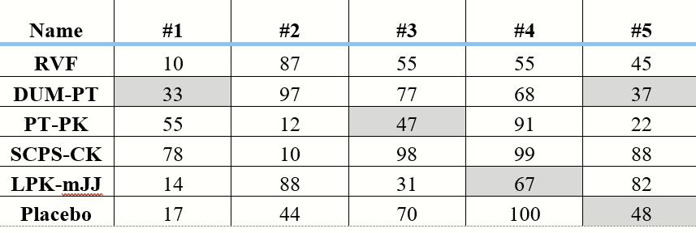

III. Conclusion
A short recap about the utilized methods and the innovations should be written here.
References
- J. U. Duncombe, “Infrared navigation—Part I: An assessment of
- R. Fardel, M. Nagel, F. Nuesch, T. Lippert, and A. Wokaun, “Fabrication of organic light emitting diode pixels by laser-assisted forward transfer,” Appl. Phys. Lett., vol. 91, no. 6, Aug. 2007, Art. no. 061103.
- http://opencv.org
- https://freertos.org

Address: Tehran, Kordestan Highway, National RoboCup Committee Correspondence email (Leader’s email): sample@iranopen.ir 1. Leader 2. Member 3. Member

